3D Shapes

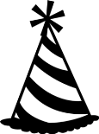
3D shapes are fat not flat.
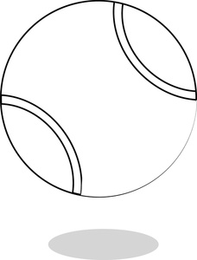
A cone is like a party hat.
A sphere is like a bouncy ball.
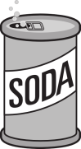
A rectangular prism is like a building tall.
A cylinder is like a can of pop.
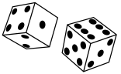
A cube is like the dice you drop.
3D shapes are here and there.
3D shapes are everywhere!

