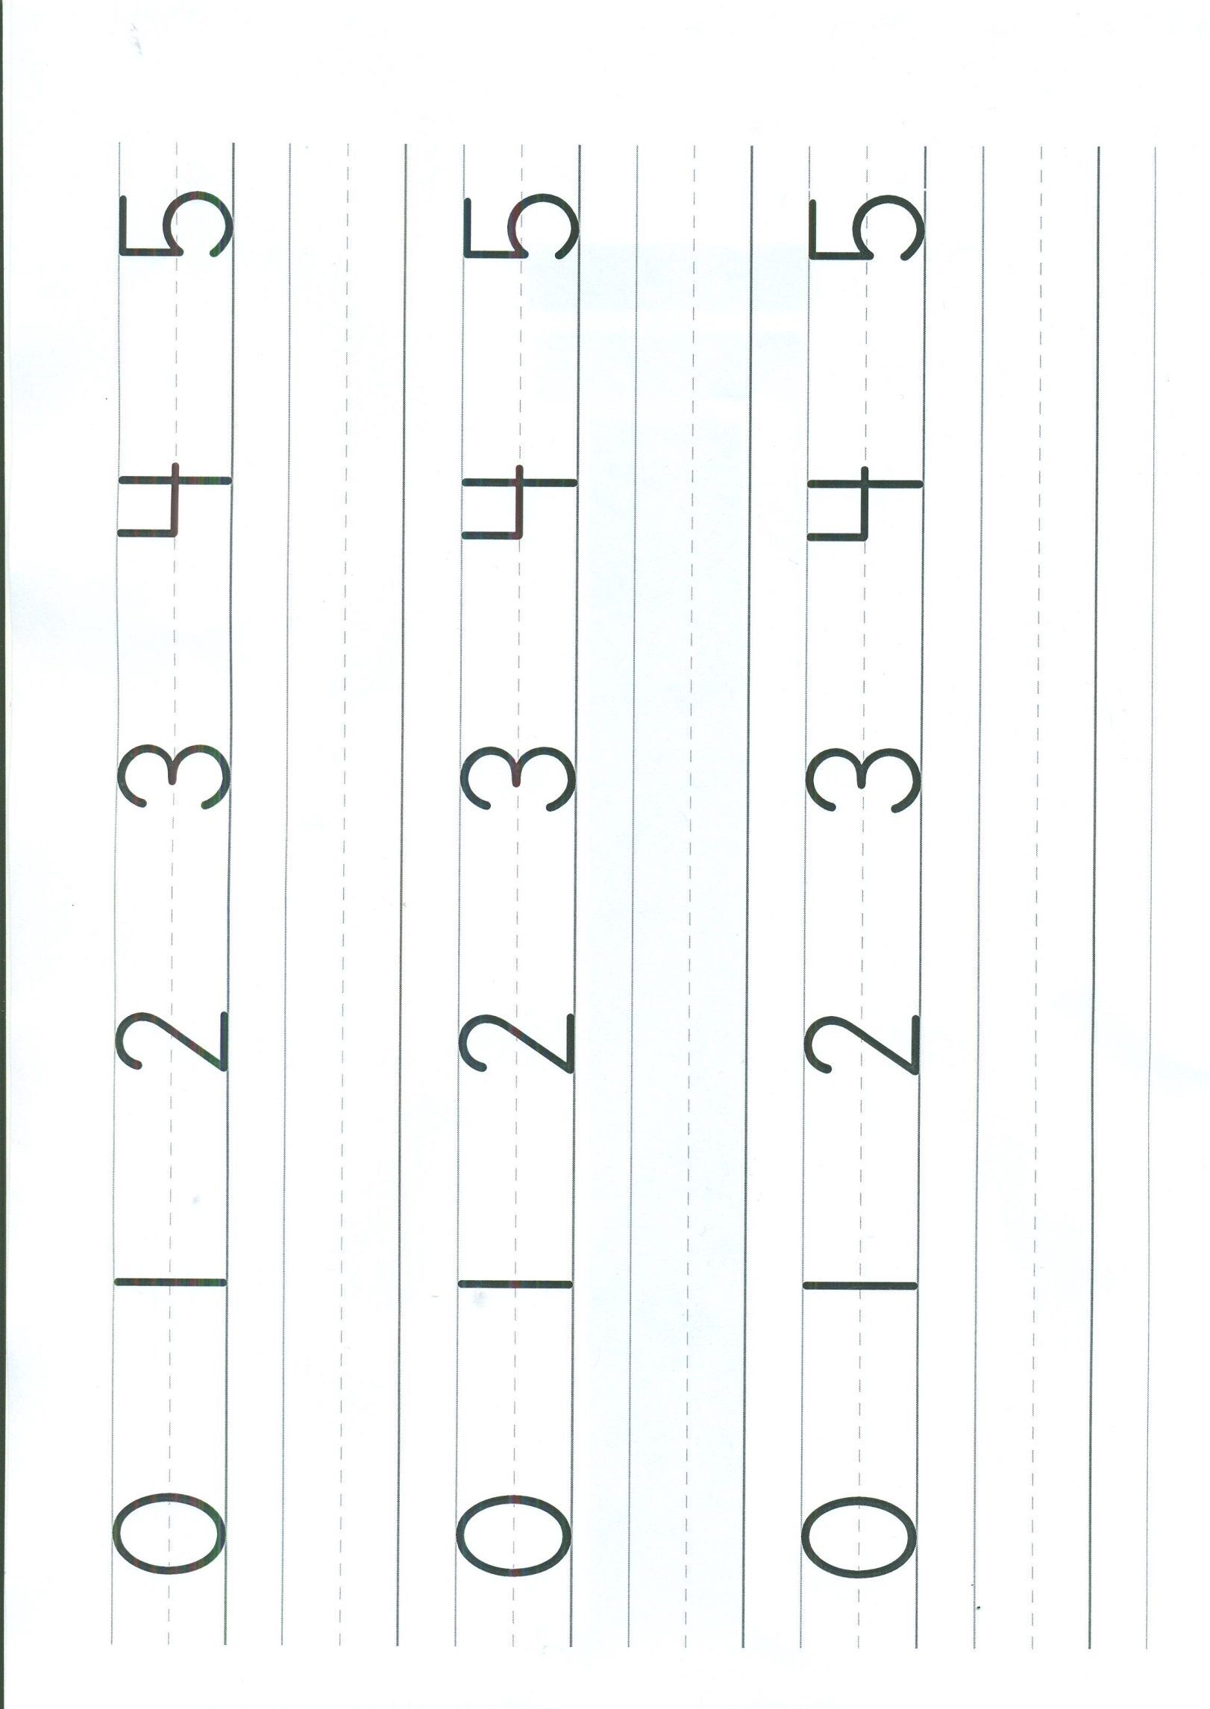Name ____________________________________________________________ Date __________________________________________

