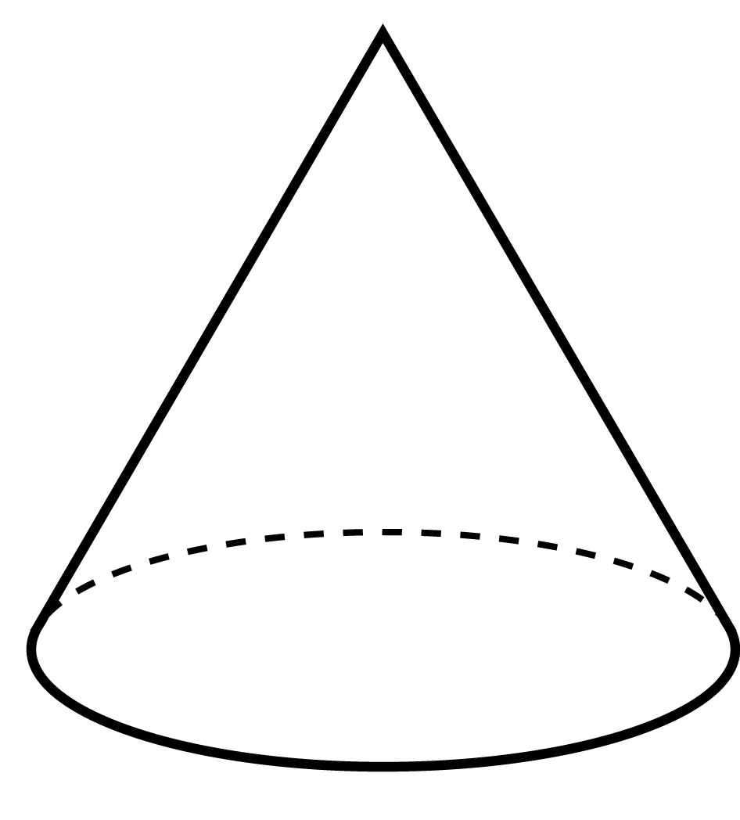
3-D Shape Hunt!

Dear kindergarten parents,
We have been learning all about 3-D shapes and the students are becoming “3-D shape experts”! The shapes that we have been working with are the sphere, cylinder, cone, cube, and rectangular prism.
For an upcoming lesson, we are asking students to participate in an at-home 3-D shape hunt. Please help your child look around the house and see if they can find one or two 3-D shapes to bring in and share with the class. Some examples are dice, party hats, boxes, and cans. The more creative, the better! Label each shape with your child’s name so we can ensure that it will be returned to your child.
This will be a great opportunity for your child to share what they know about 3-D shapes. Please bring in all shapes by ___________________________. Thank you for your participation and happy hunting!

_______________________

