Name __________________________ Date________________

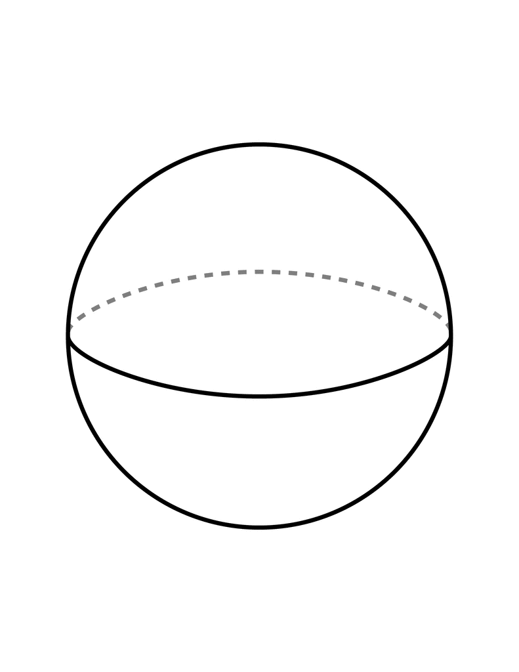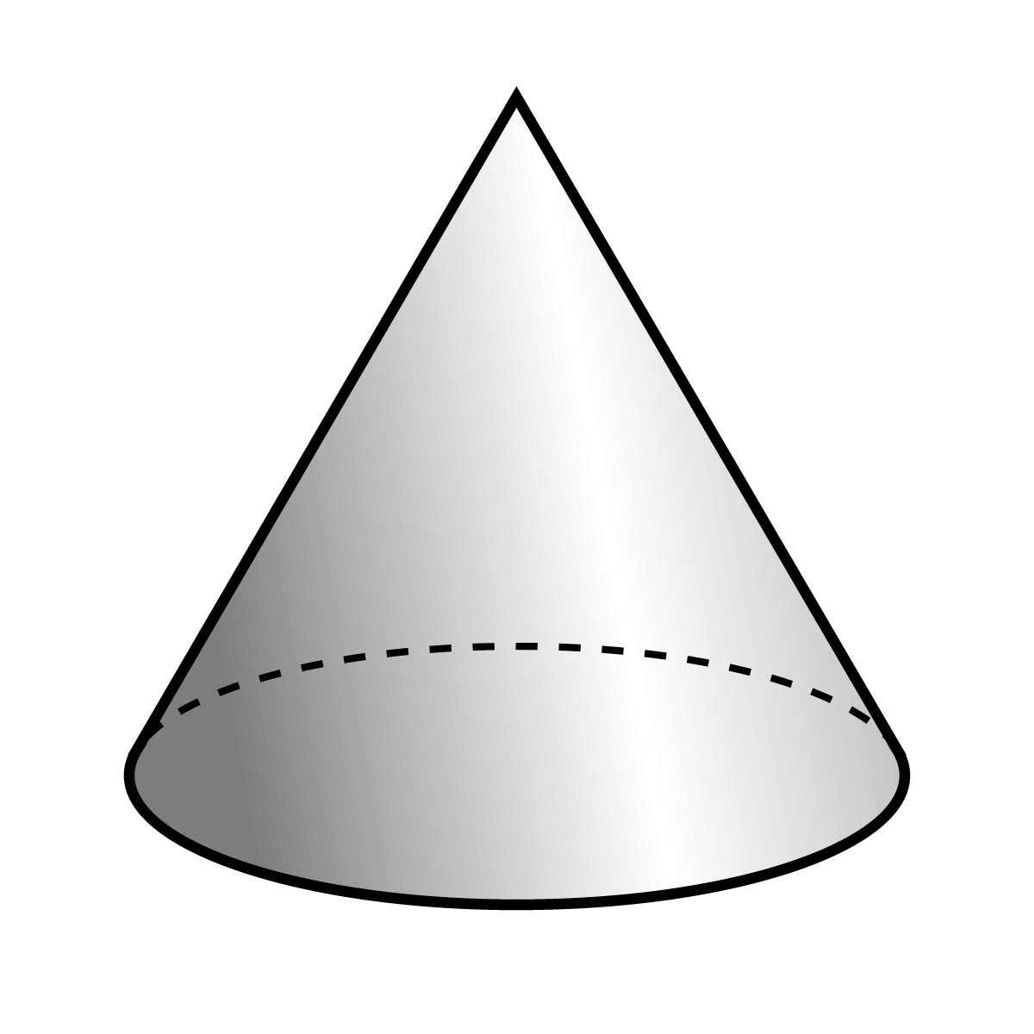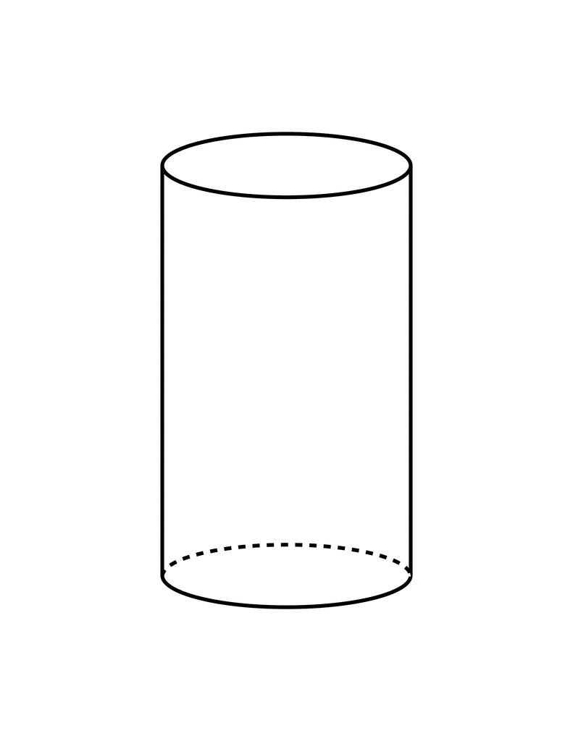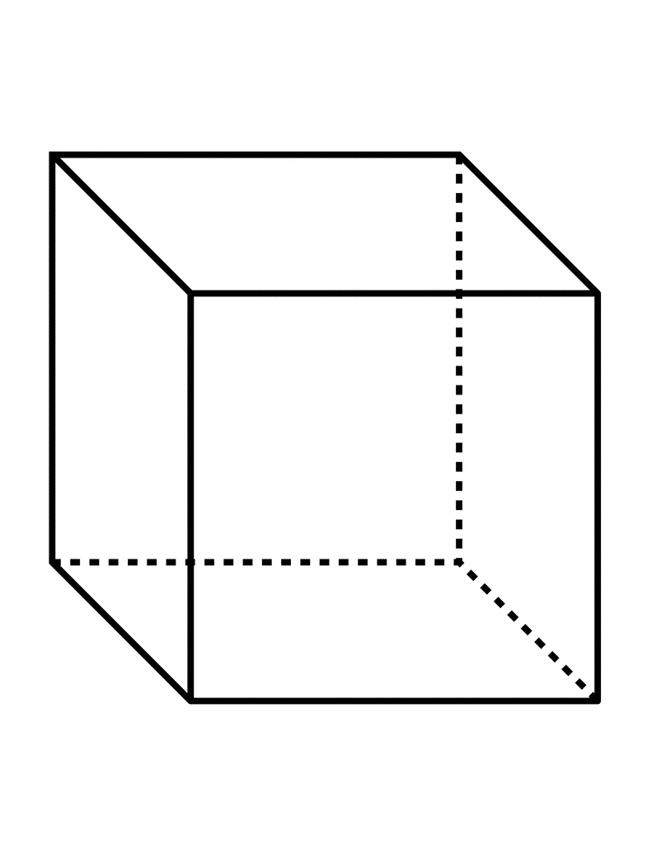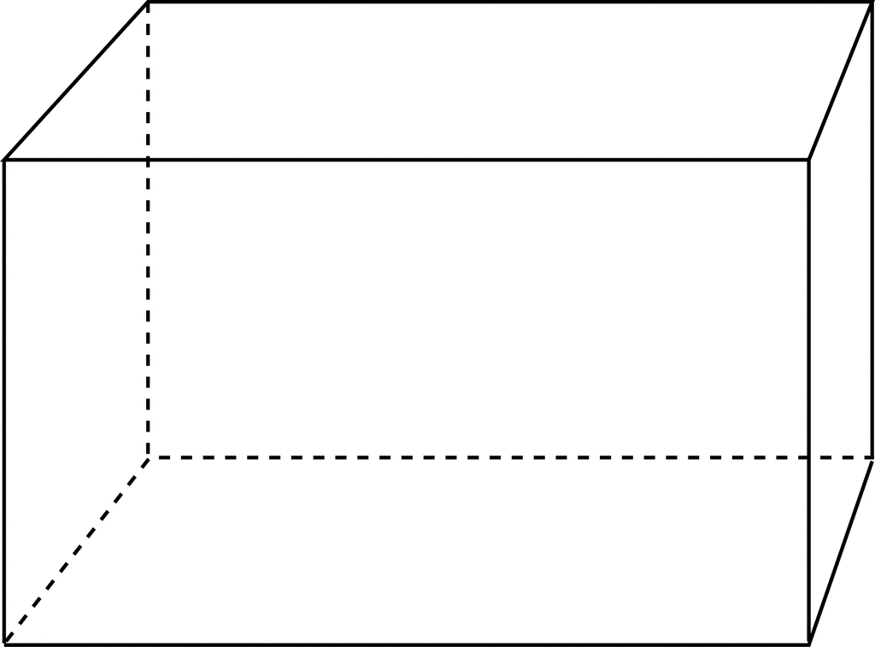

Sphere

Sphere

Cone

Cone

Cube

Cube

Rectangular Prism

Rectangular Prism

Cylinder

Cylinder

**Does it roll?**

**Does it stack?**

