GR 2 U7 L15 S2 Telling time I KEY

Draw the minute hand for each digital time given.

1. 2.

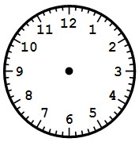

7 | 15
10 | 35

3. 4.

1 | 20

3 | 50

Write the number of minutes shown on each clock in the box next to the hours.

5. 6.

5 | 15

10 | 05

7. 8.

9 | 35

1 | 50

