GR 2 U7 L16 S1 Telling time II KEY

Write the time from the clocks pictured.

- 2. 3.

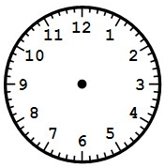

5 | 10
10 | 30

1 | 15

4. 5. 6.

1 | 50
9 | 05

4 | 40

7. 8. 9.

2 | 35
8 | 25
5 | 00

Draw the hour and the minute hand for each digital time given.

10. 11. 12.

7 | 20
2 | 55

10 | 45

