GR 2 U7 L16 S1 Telling time II Name ______________________________ Date ________________

Write the time from the clocks pictured.

- 2. 3.

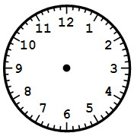

4. 5. 6.

7. 8. 9.

Draw the minute hand for each digital time given.

10. 11. 12.

7 | 20
2 | 55

10 | 45

