Telling time III
Name ______________________________ Date ________________

Circle a.m or p.m.

- I eat breakfast. a.m or p.m

- We have reading. a.m or p.m

- I go to sleep. a.m or p.m

Say the time shown on the clock using numbers and using words.
(4-7)

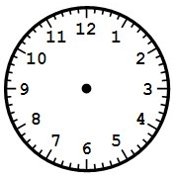

Using numbers: _________________
Using words: ___________________

Using numbers: _________________
Using words: ___________________

Using numbers: _________________ Using numbers: _________________

Using words: ___________________ Using words: ___________________

Show on the clocks below each time given in words.

8. 30 minutes after 4 9. 20 minutes before 6

10. Challenge question: Suppose it is now 25 minutes before 5:00 and your mom is serving dinner in 30 more minutes. At what time is your mom serving dinner? Explain your thinking.

