Telling time IV

Name ______________________________ Date ________________

- Write the time shown on each clock. Use half past, quarter past, or quarter of.
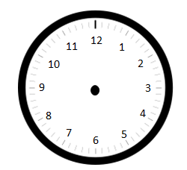

_________________________________

b.

_________________________________

c.

_________________________________

d.

_________________________________

- Show the correct time on the clocks below.

a. b.

Quarter past 10 Half past 5

c. d.

Quarter before 1 25 before 2

Challenge problem: How many minutes is it from quarter after 2 until half past 3?

