What is the value of the coins below?

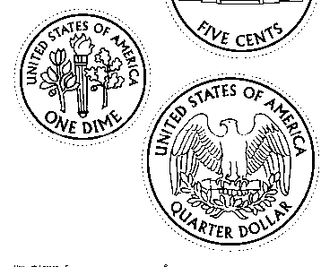1)

MCBS00590_0000[1] MCBS00590_0000[1]

[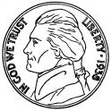](http://images.google.com/imgres?imgurl=www.hausercoin.com/5CJEFFO.gif&imgrefurl=http://www.hausercoin.com/jefferson_nickels.htm&hl=en&h=450&w=450&prev=/images?q=nickels&start=320&svnum=10&hl=en&lr=&ie=UTF-8&oe=UTF-8&sa=N)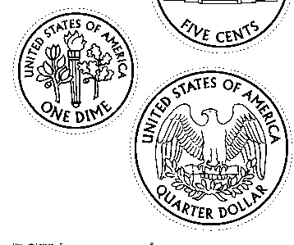2) 

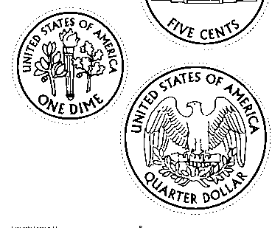 **3)**   MCBS00590_0000[1] MCBS00590_0000[1] MCBS00590_0000[1] MCBS00590_0000[1]



MCBS00590_0000[1]

4)

[](http://images.google.com/imgres?imgurl=www.hausercoin.com/5CJEFFO.gif&imgrefurl=http://www.hausercoin.com/jefferson_nickels.htm&hl=en&h=450&w=450&prev=/images?q=nickels&start=320&svnum=10&hl=en&lr=&ie=UTF-8&oe=UTF-8&sa=N)    