Name _________________________________ Date ________________

Morning meeting Start time End time

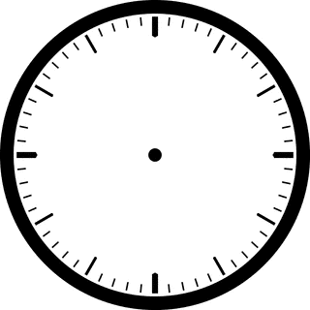

Reading Workshop

Math time

Start time End time

Music

Science

Lunch

Writing

Recess

