**GR 2 U7 L20 S1 KEY**

**Name \_\_\_\_\_\_\_\_\_\_\_\_\_\_\_\_\_\_\_\_\_\_\_\_\_\_\_\_\_\_\_\_\_\_\_\_\_\_\_ Date: \_\_\_\_\_\_\_\_\_\_\_\_\_\_\_\_\_**

**Circle the best answer.**



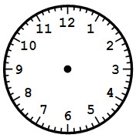

The clock on the left shows:

Quarter past 8

Quarter past 7

**Quarter to 8**

1. Which statement makes the most sense?

Sue eats lunch at 7:00 PM.

Sue reads at 5:00 AM.

**Sue brushes her teeth at 8:00 AM**.

1. Which statement makes the most sense?

The length of a pencil is about 7 yards.

**The height of a classroom door is about 2 meters.**

The length of the teacher’s desk is about 9 inches.

1. It is quarter till 12. Show this time on the digital clock below.

|  |  |
| --- | --- |
| **11** | **45** |

1. It is 30 minutes past 6.

Show the time on the clock on the right.



\_\_\_\_\_\_\_\_\_\_\_\_\_\_\_\_\_\_\_\_\_\_\_\_\_\_\_\_\_\_\_\_\_\_\_\_\_\_\_\_\_\_\_\_\_\_\_\_\_\_\_\_\_

1. Use a centimeter ruler. Measure the length of the line segment.

It is \_\_\_\_\_\_ centimeters long.

NA00648_

1. Use a 12-inch ruler. Measure the height of the flower below (top to stem).

It is \_\_\_\_\_\_ inches tall.

.

1. Answer the question using the line plot below.

**Heights of the children in a classroom**

**X**

**X**

X

X X

X X X

X X X X

X X X X X

40 45 50 55 60

**Inches**

How many more 55 inch high students are in the classroom than 50 inch students? **3 more students**

1. Jan’s plant was 12 inches long last month

It grew 7 inches since then. How long is it now?

1. inches
2. 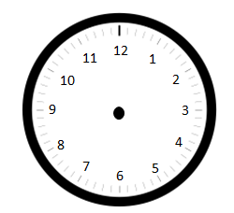Draw the hands on the clock to show the correct time.

A quarter to 3

12:15

Half past 7

\_\_\_\_\_\_\_\_\_\_\_\_\_\_\_\_\_\_\_\_\_\_\_\_\_\_\_\_\_\_\_\_\_\_\_\_\_\_\_\_\_\_\_\_\_\_\_\_\_\_\_