**GR 2 U7 L20 S1**

**Name \_\_\_\_\_\_\_\_\_\_\_\_\_\_\_\_\_\_\_\_\_\_\_\_\_\_\_\_\_\_\_\_\_\_\_\_\_\_\_ Date: \_\_\_\_\_\_\_\_\_\_\_\_\_\_\_\_\_**

**Circle the best answer.**



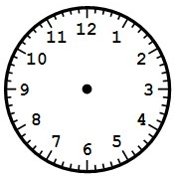

The clock on the left shows:

Quarter past 8

Quarter past 9

Quarter of 9

1. Which statement makes the most sense?

Amy eats lunch at 8:00 p.m.

Amy has math at 11:00 p.m.

Amy gets up for school at 7:00 a.m.

1. Which statement makes the most sense?

The length of a pencil is about 7 kilometers.

The height of a classroom door is about 2 meters.

The length of the teacher’s desk is about 9 centimeters.

1. It is half past 11. Show this time on the digital clock below.

|  |  |
| --- | --- |
|  |  |

1. It is 20 minutes before 5.

Show the MINUTE HAND on the clock on the right.



\_\_\_\_\_\_\_\_\_\_\_\_\_\_\_\_\_\_\_\_\_\_\_\_\_\_\_\_\_\_\_\_\_\_\_\_\_\_\_\_\_\_\_\_\_\_\_\_\_\_\_\_\_

1. Use a centimeter ruler. Measure the length of the line segment.

It is about \_\_\_\_\_\_ centimeters long.

1. Use a 12-inch ruler. Measure the height of the flower below (top to stem).

It is \_\_\_\_\_\_ inches tall.

NA00648_

.

1. Answer the question using the line plot below.

**Heights of the plants in my garden**

X

X X

X X X

X X X X

X X X X X

6 7 8 9 10

**Inches**

How many more 8 inch high plants are in my garden than 10 inch plants? \_\_\_\_\_\_\_\_\_

1. Jan’s puppy was 7 inches long last month

It grew 4 inches since then. How long is it now? \_\_\_\_\_\_\_inches

1. 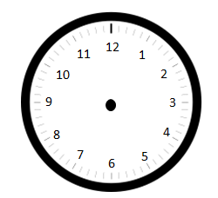Draw the hands on the clock to show the correct time.

A quarter to 3

12:15

Half past 7

\_\_\_\_\_\_\_\_\_\_\_\_\_\_\_\_\_\_\_\_\_\_\_\_\_\_\_\_\_\_\_\_\_\_\_\_\_\_\_\_\_\_\_\_\_\_\_\_\_\_\_\_\_