GR 2 U7 L20 S1

Name _______________________________________ Date: _________________

Circle the best answer.

The clock on the left shows:
Quarter past 8
Quarter past 9
Quarter of 9

- Which statement makes the most sense?
Jack goes to bed at 8:00 p.m.
Jack has math at 11:00 p.m.
Jack gets up for school at 8:00 p.m.

- Which statement makes the most sense?
The length of a pen is about 7 centimeters.
The height of your bedroom door is about 2 centimeters.
The length of the student’s desk is about 9 meters.

- It is half past 2. Show this time on the digital clock below.

- It is 10 minutes before 4.
Show the MINUTE HAND on the clock on the right.
***********************************************************

- Use an inch ruler. Measure the length of the line segment.

It is about ______inches long.

- Use a centimeter ruler. Measure the height of the girl.
She is ______ cm. tall.

_________

- Answer the question using the line plot below.
Weights of pumpkins
X
X
X X X
X X X X
X X X X X
6 7 8 9 10
Pounds

How many more 9 pound pumpkins are in my garden than 7 pound pumpkins? _________

- Alex’s tomato plant was 6 inches high last month
It grew 3 inches since then. How long is it now? _______inches

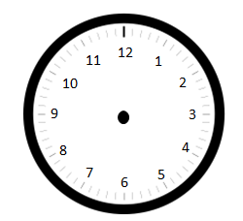
- Draw the hands on the clock to show the correct time.

A quarter to 3
12:15
Half past 7
____________________________________________________

