GR 2 U7 Skills Assessment KEY Scoring: Each answer is worth 2 points, for a total of 20 points

Circle the best answer.

The clock on the left shows:
Quarter past 8
Quarter past 9
Quarter of 9

- Which statement makes the most sense?
Amy eats lunch at 8:00 p.m.
Amy has math at 11:00 p.m.
Amy gets up for school at 7:00 a.m.

- Which statement makes the most sense?
The length of a pencil is about 7 kilometers.
The height of a classroom door is about 2 meters.
The length of the teacher’s desk is about 9 centimeters.

- It is half past 11. Show this time on the digital clock below.
11 | 30

- It is 20 minutes before 5.
Show the MINUTE HAND on the clock on the right.

Do not penalize if they show both hands.
_____________________________________________________
- Use a centimeter ruler. Measure the length of the line segment.

It is about 10 centimeters long.

- Use a 12-inch ruler. Measure the height of the flower below (top to bottom).
It is 4 inches tall

8. Answer the question using the line plot below.
Heights of the plants in my garden
X
X X
X X X
X X X X
X X X X X
6 7 8 9 10
Inches

How many more 8 inch high plants are in my garden than 10 inch plants? 3

- Jan’s puppy was 7 inches long last month
It grew 4 inches since then. How long is it now? 11 inches

- Jan’s puppy was 7 inches long last month. It grew 4 inches since then. How long is it now?
11 inches

- Draw the hands on the clock to show the correct time.

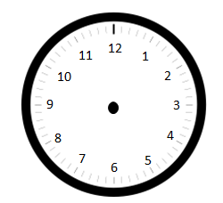

10:15 Half past 3

