Name__________________________ Date _________________

A. Find the value of each set of coins:
1.
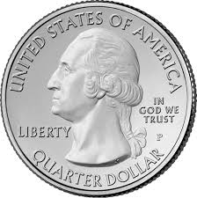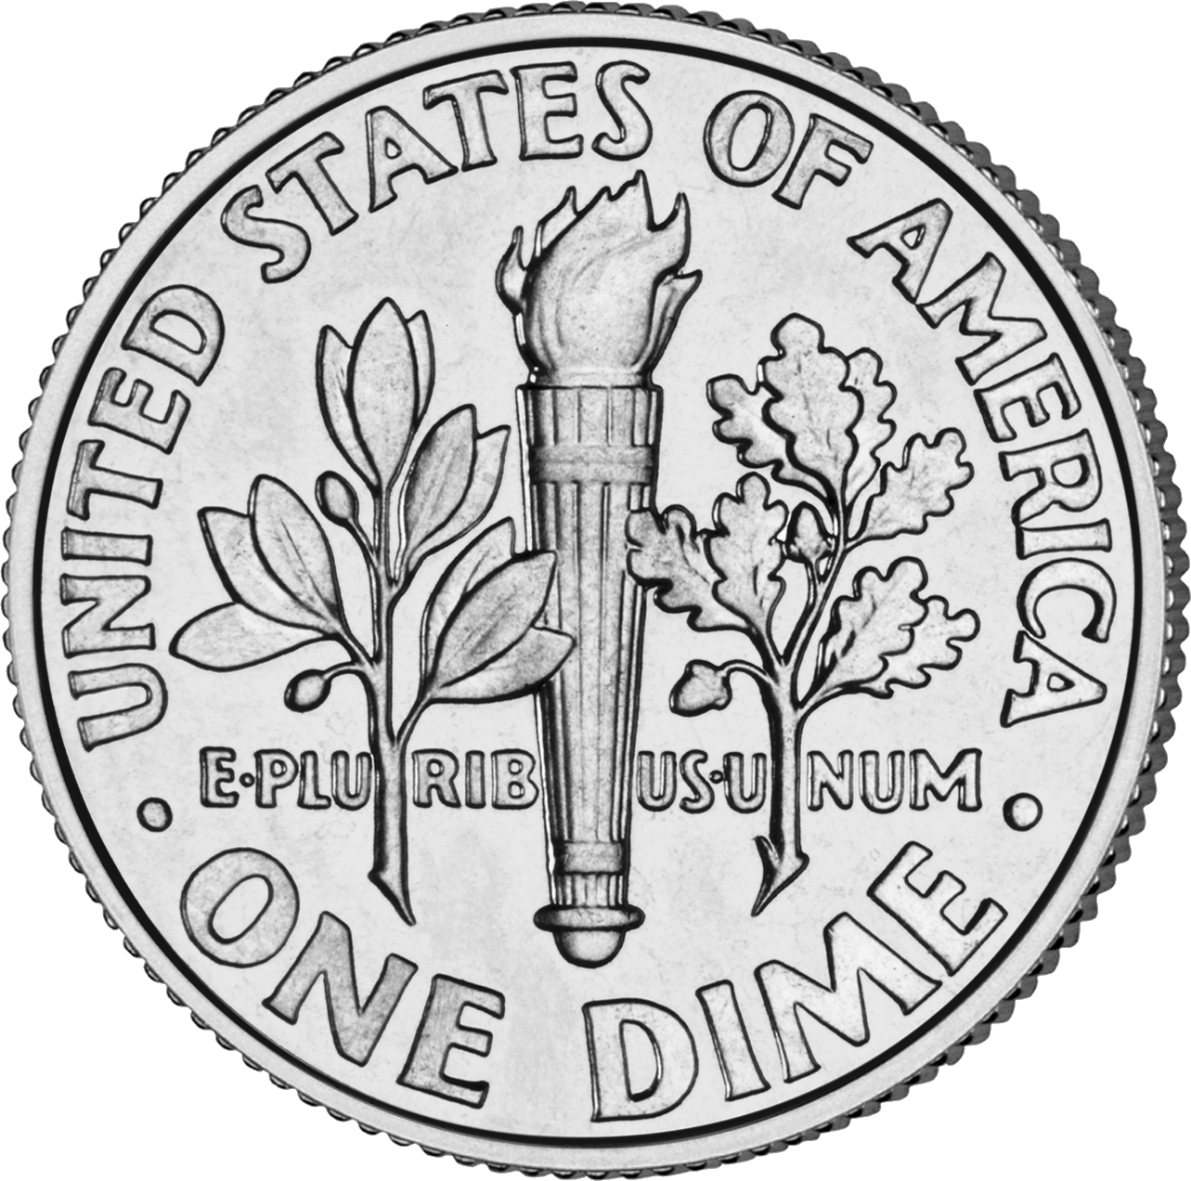
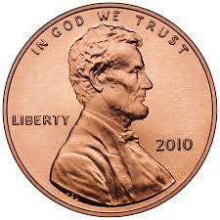

Value = _________

2. 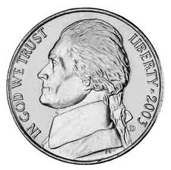

Value = _________
B. Find the value of set of coins described. Write as an amount of money.
1. one quarter, 3 nickels, and 2 pennies Value = _________

2. 6 dimes, 5 nickels, and 4 pennies Value = _________

3. 2 quarters, 4 nickels, and 6 pennies Value = _________

4. 1 quarter, 1 nickel, and 4 dimes Value = _________

Challenge: Can you find a set of six coins that has a value of 51 cents?

