GR2 U3 L7 S1 Finding the value of a set of mixed coins KEY
A. Find the value of each set of coins:
1.
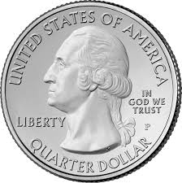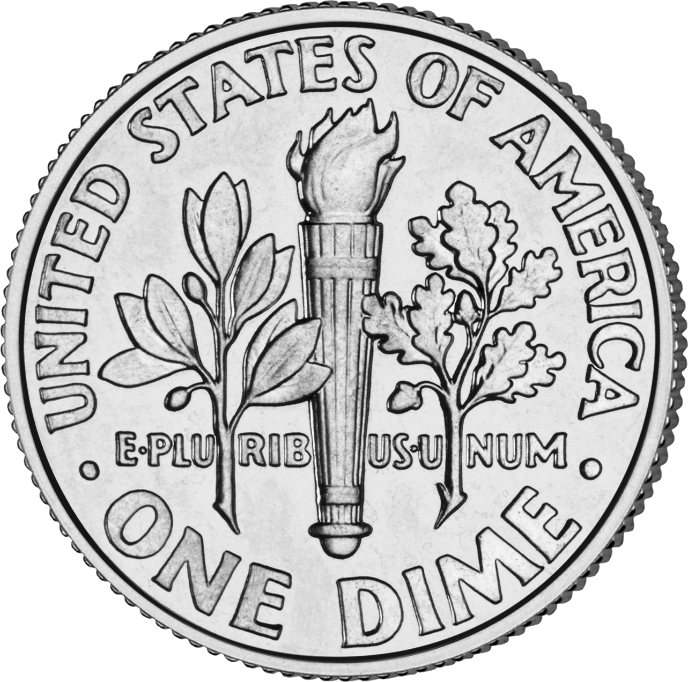
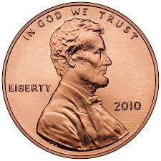

Value = 55 cents

2. 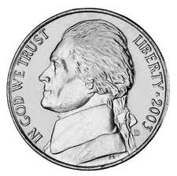

Value = 44 cents

B. Find the value of set of coins described. Write as an amount of money.
1. one quarter, 3 nickels, and 2 pennies Value = 42¢

2. 6 dimes, 5 nickels, and 4 pennies Value = 89¢

3. 2 quarters, 4 nickels, and 6 pennies Value = 76¢

4. 1 quarter, 1 nickel, and 4 dimes Value = 70¢

Challenge: Can you find a set of six coins that has a value of 51 cents?
One quarter, 3 nickels, one dime, and one penny

