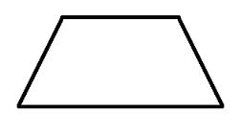2 Dimensional Shapes

Gr 2 U6

Rhombus

Pentagon

Hexagon

Rectangle

Trapezoid

Circle

Triangle

Square