Definition sheet for reference:
cylinder | A 3-D figure with  - 2 parallel and congruent circles as bases  - One curved surface  - Two curved edges  - No vertices
cube | A 3-D figure with  - 6 congruent square faces
rectangular prism  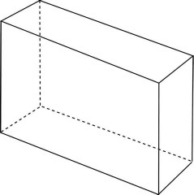 | A 3-D figure with  - 6 rectangular faces  - Opposite faces are congruent and parallel
pyramid  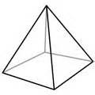 | A 3-D figure with  - A polygon base  - The other faces are all triangles that share a common vertex
cone  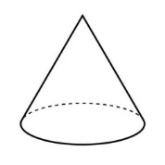 | A 3-D figure with  - One flat base (usually circular)  - One curved surface  - One curved edge  - One vertex
sphere  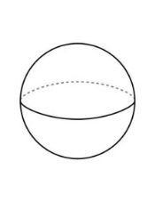 | A 3-D figure made up of all points that are equally distant from a point called the center

