Name _________________ Date _________ **Subtracting 3-digit numbers using an algorithm**

1. Jennifer’s book has 396 pages. She has already read 139 pages.

How many pages does Jennifer have left to read?

1. Alex wants to do 125 sit-ups without stopping. Today he did

107 sit-ups. How many more sit-ups does Alex have to do to

reach his goal?

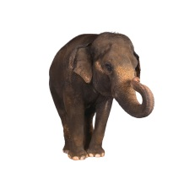

1. An elephant eats 250 lb of plants a day. If an elephant eats 160 lb

of plants in the morning, how many more pounds of plants will he

eat that day?

1. There are 365 days in one year. If 197 days have passed since the

beginning of the year, how many days are left in the year?

1. C:\Users\mbonenfant\AppData\Local\Microsoft\Windows\Temporary Internet Files\Content.IE5\C1TCL4HS\MC900320954[1].wmfThe fastest train traveled at 252 mi per hour. The fastest automobile

traveled at 205 mi per hour. What is the difference between the

speeds of the fastest train and the fastest automobile?

1. There are 206 bones in the human body. The backbone is made up of

33 bones called the vertebrae. How many of the body’s bones are not

vertebrae?