[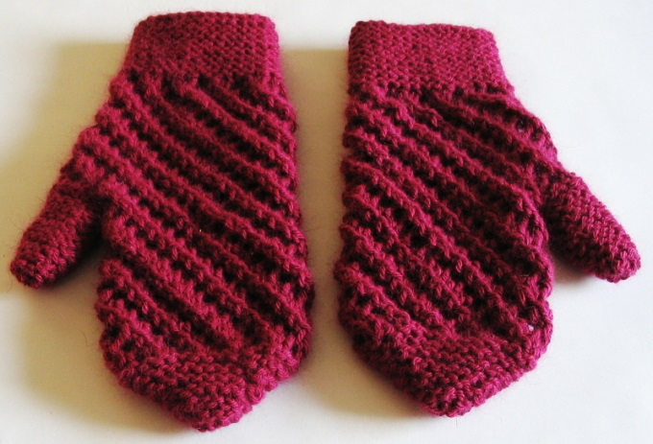](http://www.google.com/url?sa=i&rct=j&q=mittens&source=images&cd=&cad=rja&docid=CDqM0GgJ6VUEtM&tbnid=o8xlKa97ss3aUM:&ved=0CAUQjRw&url=http://www.yanaknits.com/projects/raspberry-scarf-and-mittens/&ei=7jfxUYC3KYf49gS0ioHgAQ&bvm=bv.49784469,d.eWU&psig=AFQjCNGSlk_BgPBX9MwjXUlZpSlGMWxRGA&ust=1374849387392463)

[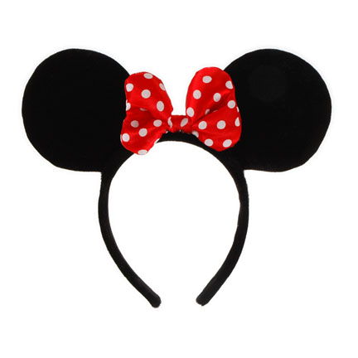](http://www.google.com/url?sa=i&rct=j&q=minnie+mouse+ears&source=images&cd=&cad=rja&docid=3kTA3MdlPXzlgM&tbnid=phTFn-IviB0IuM:&ved=0CAUQjRw&url=http://www.halloweenplayground.com/disney-minnie-mouse-ears-with-red-bow-pi-6447.html&ei=MzjxUdihLYX08ASGjYHgCw&bvm=bv.49784469,d.eWU&psig=AFQjCNFRqVYtYimGQOJRh8G8t4SWQFP9cw&ust=1374849456679094)[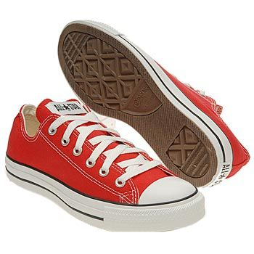](http://www.google.com/url?sa=i&rct=j&q=shoes&source=images&cd=&cad=rja&docid=nOSJZlAPNdlxVM&tbnid=B5of4GBWMQ9IIM:&ved=0CAUQjRw&url=http://www.nj.com/indulge/index.ssf/2012/08/famous_footwear_offers_back_to.html&ei=vTfxUdPbM43k8gSrqoDABg&bvm=bv.49784469,d.eWU&psig=AFQjCNHtDu950E4kXb9imCBds__A55YhAA&ust=1374849324750145)