Name _______________________________________________________ Date_______________________________
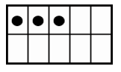
3 3 3 3
3 3 3 3 3 3 3 3 3 3 3 3 3 3

