Finger Cubes

It was the third day of Kindergarten. Quinn was big enough to go to school. He was also happy that his best friend and neighbor, Sara, was in his class. The teacher, Miss Serene, had placed tubs of cubes on the tables. She explained that today the students were going to build with the cubes. Quinn was excited because he loves to build things.

Quinn stuck his hand in the tub and pulled it out. He held up his hand and said, “Hey look Sara! I have a cube on each finger.”

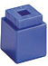

Sara stuck her hand in and did the same and then said, “Me too! How many do you do you have on you hand?”

Quinn starting counting, “1, 2, 3, 4, 5.”
Sara asked, “So how many do you have all together?”

Quinn announced, “I have 5!”

Sara smiled, reached over and pulled one off his thumb. “Now how many do you have Super-Counter Quinn?” she teased.
Quinn quickly said, “4.”
“How do you know that so fast?” Sara was amazed.
“I saw 2 on these fingers and 2 on these fingers,” he said as he put his fingers together, “and that is 4!” he claimed.
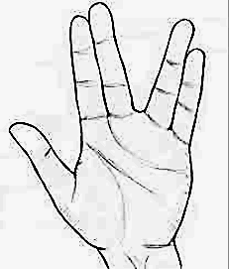
Sara looked at his hand and pointed to his thumb. “I saw this in a different way. You have 5 fingers and 1 finger has no cube so 1 less than 5 makes 4.”
Then Sara said, “Hey, can we make more than 5?”
“I think so,” said Quinn as he thought. He stuck his other hand into the tub. He pulled out three more cubes.
He put one cube back on his thumb.
“Now I have 5 again.”
Sara asked, “Now how do we make more than 5?”
Quinn waved his other hand. “I can use my other hand.”
Sara said, “Of course you can put the other two cubes on your other hand.”
Quinn put two cubes on his other hand. He held up one hand and said, “5.”
Then he held up his other hand and said, “six, seven!”
Miss Serene came over to the table and asked, “What are you two building?
“Numbers!” Sara and Quinn both exclaimed at the same time. Then they looked at each other and began to laugh.
“Do you want to see?” Sara asked Miss Serene.
“I’d love to.” replied Miss Serene.

