Attendance Routine: The following example uses a class of 23 students
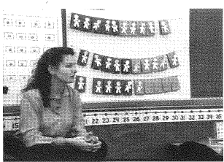
Create a class set of name cards (photos optional) to be placed on one of two colors (i.e. red and white – similar to a math rack -See below.) Ask students to sit in the meeting area where all can see the display and provide each with their name card. Explain that every day we come to school we need to see if everyone is here. As you take attendance, ask the students to place their names in a pocket chart, easel, post on the board or manipulate on SmartBoard. Ask students to count while they arrange their names on the display.
klhsfw
klhsfw
klhsfw
asdfojh
klhsfw
klhsfw
klhsfw
klhsfw
asdfojh
asdfojh
asdfojh
klhsfw
asdfojh
asdfojh
klhsfw
asdfojh
klhsfw
klhsfw
klhsfw
asdfojh
asdfojh
klhsfw
klhsfw

CFLM: Bunk Beds and Apple
Boxes p. 15

Then ask children how many are in each row. Ask how they know and count from one to double check. Then ask how many groups of ten (full rows) are displayed and how many more. Initially demonstrate on a chart with linear ten-frames (groups of ten) and how many more in another ten-frame (See below). Ask students how many students are here today and how many are not here today. Then place numeral cards under the ten-frames to match your class count. If a child is absent, explicitly model changing the 3 to a 2 and moving the 1 to the absent column and adjust your ten-frames to match.

Here Today Not Here today
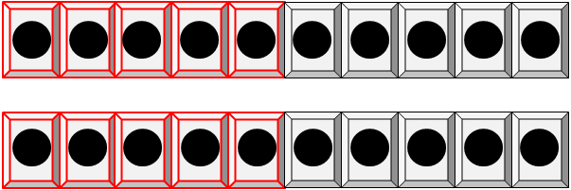
Groups of Ten and How many more?
0
3
2

The goal is to encourage students to recognize the five- and ten-structure over time and to use that structure to determine the student count. Eventually, you will want to ask if they notice any patterns with the number of groups of tens and ones (how many more) as the number students who are absent changes on any given day. This will reinforce lessons they will later receive on composing and decomposing numbers, i.e. 23 can be thought of as 22 and 1.

Counting the Days in School-This is another activity that can be done to encourage rote counting by one’s, fives, and tens.

Use or create a number line that alternates colors every count of five, e.g. 1-5 red, 6-10 white, 11-15 red, 16-20 white,…176-180 white.
Suspend it high enough where students can not actually touch it. As you count the number of days in school place a marker, clip with the numeral under it or write the number for each day. You can use this as a daily practice for counting from 1, 2, 3,…

Extension suggestions as the year progresses:
- Stop at five and ask what students notice. (All red)
- Stop at ten and ask what students notice. (red and white)
- Stop at ten and ask how many red and how many white and compare
- If the day is not a benchmark number of 5 or 10 ask how many more to get to the next 5 or 10 or how many fewer than the next 5 or 10.
- Ask what color patterns they notice as you count
- Ask if there is an easy way to figure out how many days we’ve already counted
- What happens to the number after you get to 9?
- What happens to the number after you get to 19, 29, 39,…?
- Ask students to describe how to figure out day 11, 21, 31 without counting by one
- If you placed a clip on the day’s count, ask if you removed all the numbers except multiples of 5 (5, 10, 15, 20,…) if they could figure out what day it is just using the 5 benchmarks numbers.
- Place a clip on the day’s count. What if you only had the ten benchmark numbers labeled how could they figure out the count?
- What patterns do they notice in the counting numbers as they progress through the decades – 21, 22, 23,…31, 32, 33,…41,42,43,…?
- What do they notice happening to the tens place through the decades?
- What is five more/less than a number and how did you figure it out?
- What is ten more/less than a number and how do you know you are correct?
- What pattern do you notice if you start on a non-benchmark number (i.e. 11) and jumped ten more and ten more again and again? Does the same pattern emerge if you do the same process with any non-benchmark number?
- What happens to the number after you get to 99?
- What happens to the number after you get to 109, 119, 129,…?

