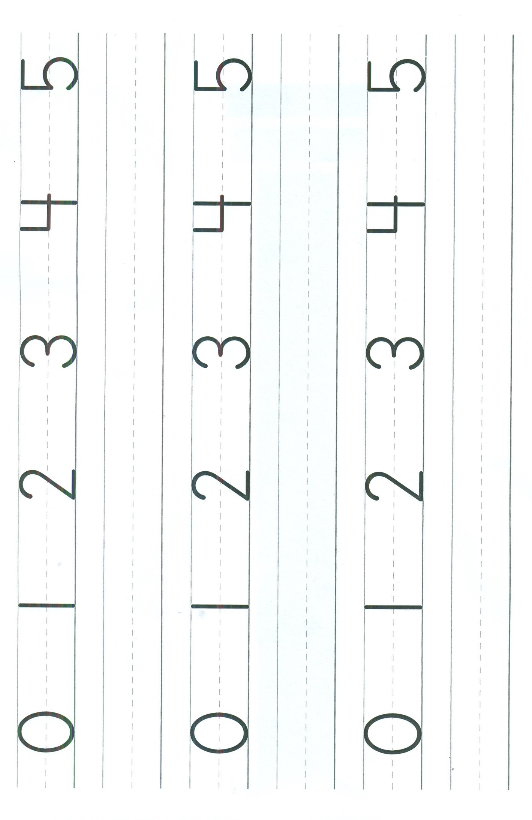
Name ____________________________________________________________ Date __________________________________________

