[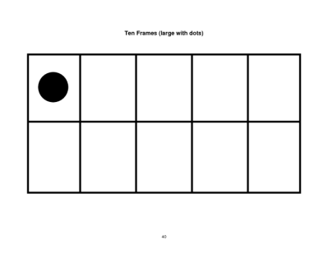](http://www.google.com/url?sa=i&rct=j&q=ten+frame+1&source=images&cd=&cad=rja&docid=GSTjdH44mPcdnM&tbnid=LYSdbx27hE4oHM:&ved=0CAUQjRw&url=http://www.docstoc.com/docs/29776112/Tens-Frame-Ten&ei=PtXeUd_TMPLE4APGqoCoDg&bvm=bv.48705608,d.dmg&psig=AFQjCNFhwjhb5EtoKhxmeBLLK-DV6z5m5A&ust=1373644476813594)

