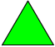

Triangle

Square

Rhombus

Rhombus
Trapezoid
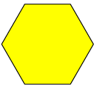
Hexagon

