Name _______________________________________________________ Date_______________________________
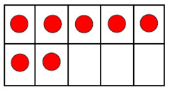
7 7 7 7 7 7 7 7 7 7 77 7 7 7 7 7 7 7

