[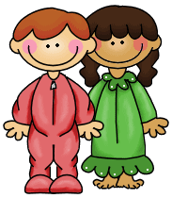](http://www.google.com/url?sa=i&rct=j&q=&esrc=s&source=images&cd=&cad=rja&uact=8&docid=75WLD86Q3nt1cM&tbnid=f92hr2Qb6eNSiM:&ved=0CAUQjRw&url=http://learningwithmrsbrannigan.com/?cat%3D144&ei=4qa6U-HJJ5SoyASnwoGwBg&bvm=bv.70138588,d.cWc&psig=AFQjCNE0pj_k9IYjX_9Jb9H9m8loU0b6Fw&ust=1404826930102854)The Sleepover

By _______________

_______ children were at a sleepover.

