Name _______________________________________________________ Date_______________________________
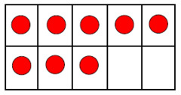
8 8 8 8 8 8 8 8 8 8 8 8 8 8 8 8 8 8 8

