C:\Users\wwakeman\AppData\Local\Microsoft\Windows\Temporary Internet Files\Content.IE5\2V7XETLE\MC900446338[1].wmfTen in a tank.

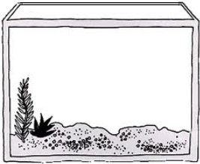

The tank has 10 and loose in the pond.

I have 10 and .

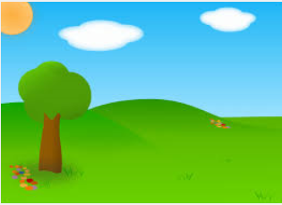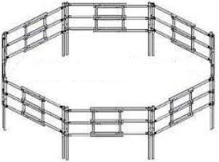Ten in a pen.

The pen has 10 and loose in the field.

I have 10 and .

C:\Users\wwakeman\AppData\Local\Microsoft\Windows\Temporary Internet Files\Content.IE5\1H9GUXW6\MC900330444[1].wmf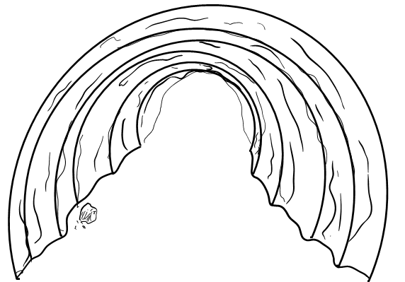Ten in a den.

C:\Users\wwakeman\AppData\Local\Microsoft\Windows\Temporary Internet Files\Content.IE5\1H9GUXW6\MC900330444[1].wmf

The den has 10 and loose in the woods.

I have 10 and .

Ten in a .

The has 10 and loose.

I have 10 and .