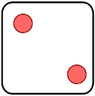  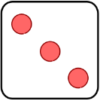  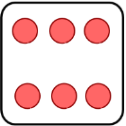  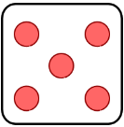  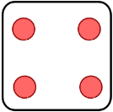 | 1 2 3 4 5 6 | 1 2 3 4 5 6 | 1 2 3 4 5 6 | 1 2 3 4 5 6 | 1 2 3 4 5 6 | 1 2 3 4 5 6 | 1 2 3 4 5 6 | 1 2 3 4 5 6
Name ____________________________________________________ Date______________________

