*Fairfield Public Schools Balanced Math Instructional Model
Grade K Unit 4 Lesson 19

 | Materials: Fluency: Number cards 10-20, counters. Lesson: Numbered doors 1-20 (Enlarged onto 11X17 paper), geometric shapes, glue
 | Fluency Work  (1-5 min.) |  | Draw a number card with numbers ranging from 10 to 20. Ask students to create that number with counters. Highlight students who placed a set of ten and the loose in an easy to visualize or organized manner. Repeat with few different numbers. Highlight students who begin to realize they can just leave their set of ten grouped and only begin to focus on changing the ones.
Teaching Point |  | Sequence numbers 1-20.
Mini-Lesson |  | Ask the students if they know the number on their house or apartment. Bring to their attention that we number our addresses to help us locate places. Ask if the students noticed that the classrooms in the school are numbered too. Tell them today we are going to make the front doors of our Geo-neighborhood. Tell them they can design their own front door by glueing/taping geometric shapes on their doors. (Make sure you enlarge the doors on 11x17 paper so students can fit the correct number of shapes on their door.) Review each of the shapes and ask students to describe how they know what the shape is by describing an attribute. Remind the students that the number and matching ten-frame need to be visible. If they have a number higher than ten then they should circle a group of ten to help them see ten and some loose.  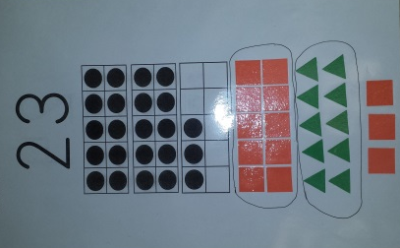  It is helpful if the teacher has a sample to demonstrate with the students. Assign numbered doors to students and ask all to recite the numbers as you pass them out. Field any questions before they set to work. If you have more than twenty students, provide selected students with numbers beyond 20. The numbers beyond twenty do not need to be discussed with the whole class at this time.  Note: Numbered “doors” are provided; however, you may want to vary this activity by using your own materials. Students could then attach the numbers and matching ten-frames after they decorate the doors. This is also an opportunity to review the geometric shapes and some of their attributes.
Focus Questions for APS |  | What number door is yours?
Active Problem Solving |  | Provide each student with a “numbered door.” Have a set of pre-cut geometric shapes that students can glue to their numbered door. As you confer, ask students about the shapes they are using and the attributes. Keep the students grounded in the context. Ask if they know what door will come before and after theirs in the K neighborhood. Have the students circle groups of ten if their number is 10 or higher.
Differentiation Suggestions |  | Differentiate this activity by providing some students with specific resources, i.e. specific geometric shapes for review. Some students may only complete one door while others can complete several. While many lessons focus less on task completion and more on the big mathematical ideas, this lesson should focus on task completion.
Assessment Point |  | Notice which students are able to identify the shapes and a related attribute. Do student know their teen number. Are they able to tell you the number that comes before and after their number? Can students recognize all the numbers of their peers at their table?
Reconvene &  Focus Q. |  | Reconvene the students in the meeting area and have each student share a numbered door. Ask other students to identify the shapes they see and the number on the doors
 | Notes |  | Collect all the doors for use in Gr K U4 L20

