Zaner Blozer Fonts

http://www.schoolhousefonts.com/demos_opentype.htm

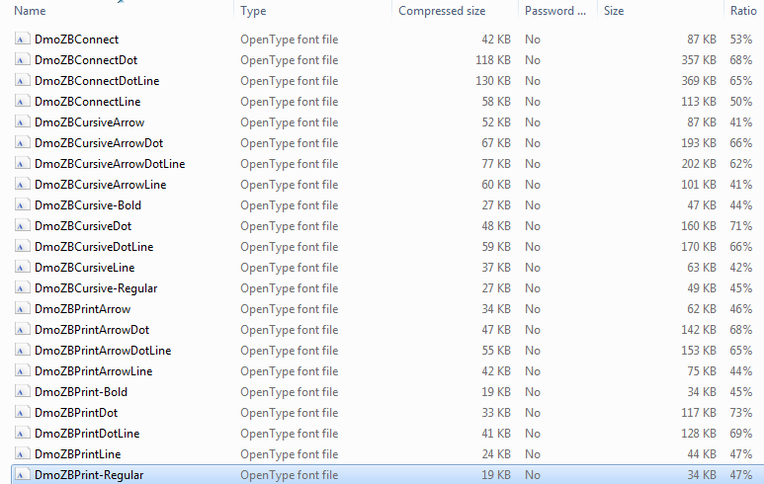

Dotted
