Name_____________________ Date_____________ ____ /20 points

- The value of one quarter is ________ cents.
- Find the value of 6 dimes: _______ cents
- Find the value of 9 nickels: _________cents
- Find the value of the coins below. _____________

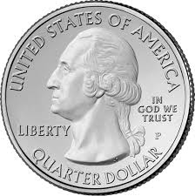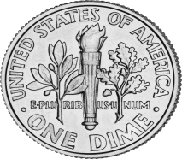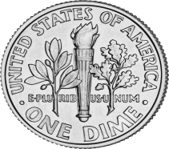

- Draw a set of coins with a total value of 67₵ in the space below and count up under each coin.

- Show the same amount in another way and count up under each coin.

7.Billy had 2 quarters, 3 dimes and 6 pennies in his pocket.
How much money did Billy have?
________________

Draw (using p, n, d, or Q) the missing coins below to make the equasions correct.
Q

8. + = = 35₵

d

9. + + + =20₵

Q

10. - = 15₵

11. + + + + = 30₵

12. $1.00 - = 75₵

d

d
13. + = + + + +

d
d

14. = + +

15. What is the correct way to write 53 pennies as an amount of money?

_______________

16. What is the correct way to write 2 dollars and 53 cents as an amount of money?

_______________

17. What is the correct way to write the total of 3 dimes, 1 nickel, and 3 pennies as an amount of money?

_______________

18. Set A has 2 dimes and 4 nickels. What is the value? ________
19. Set B has 3 dimes and 3 nickels. What is the value? _______
20. Which set of coins has the greater value? ________________

