Name_____________________ Date_____________ ____ /20 points
Score 1 point for each problem.
- The value of one quarter is 25 cents.
- Find the value of 6 dimes: 60 cents
- Find the value of 9 nickels: 45 cents
- Find the value of the coins below. 80 cents

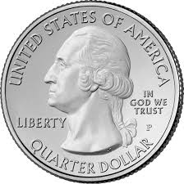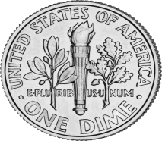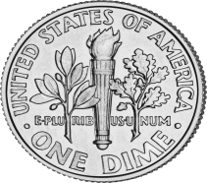

- Draw a set of coins with a total value of 67₵ in the space below and count up under each coin. Answers will vary

- Show the same amount in another way and count up under each coin. Answers will vary

7.Billy had 2 quarters, 3 dimes and 6 pennies in his pocket.
How much money did Billy have? 86 cents

Draw (using p, n, d, or Q) the missing coins below to make the equasions correct.
d
Q
8. + = = 35₵

n
d

n
9. + + + =20₵

Q
d
10. - = 15₵

d
d
n
n
11. + + + + = 30₵

Q
12. $1.00 - = 75₵

d
n
n
n
n
d
13. + = + + + +

n
d
d
Q
14. = + +

15. What is the correct way to write 53 pennies as an amount of money? 53¢

16. What is the correct way to write 2 dollars and 53 cents as an amount of money?
$2.53

17. What is the correct way to write the total of 3 dimes, 1 nickel, and 3 pennies as an amount of money? 38¢

18. Set A has 2 dimes and 4 nickels. What is the value? 40 cents
19. Set B has 3 dimes and 3 nickels. What is the value? 45 cents
20. Which set of coins has the greater value? Set A

