Name: __________________________________ Date: _________________

1. [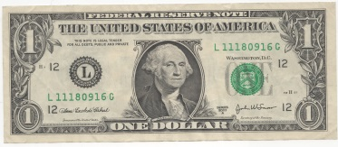](http://www.google.com/url?sa=i&rct=j&q=dollar+bill&source=images&cd=&cad=rja&docid=SfDwBd3l78CK0M&tbnid=g0pVKVDSjZkKKM:&ved=0CAUQjRw&url=https%3A%2F%2Fcommons.wikimedia.org%2Fwiki%2FFile%3AUnited_States_one_dollar_bill%2C_obverse.jpg&ei=3wXkUdzJF8H_4AOWg4GQDA&bvm=bv.48705608,d.dmg&psig=AFQjCNHeQ2U9g2vtDOt6U5ff2PSIkfhU-Q&ust=1373984606258135)A pencil costs 65 cents. You pay with

How much change should you get back? Show your thinking.

Draw the coins you might get back.

[](http://www.google.com/url?sa=i&rct=j&q=dollar+bill&source=images&cd=&cad=rja&docid=SfDwBd3l78CK0M&tbnid=g0pVKVDSjZkKKM:&ved=0CAUQjRw&url=https%3A%2F%2Fcommons.wikimedia.org%2Fwiki%2FFile%3AUnited_States_one_dollar_bill%2C_obverse.jpg&ei=3wXkUdzJF8H_4AOWg4GQDA&bvm=bv.48705608,d.dmg&psig=AFQjCNHeQ2U9g2vtDOt6U5ff2PSIkfhU-Q&ust=1373984606258135)

1. An eraser costs 87 cents. You pay with

How much change should you get back? Show your thinking.

Draw the coins you might get back.

1. An ice cream cone costs $1.30. You pay with 2 dollar bills. Draw below the coins you might get back.