Name: _____________________ Date: ___________________

1) If each stamp costs 0.08¢, how much will all the stamps cost?
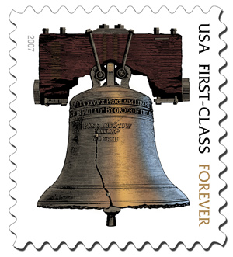

Find the product:
2) 2 x 4 = ______ 3) 5 x 5 = ________
4) 5 x 3 = ______ 5) 2 x 7 = ________

6) Draw an array to show 6 x 3. Solve.

7) Draw an array to show 9 x 5. Solve.
8) Write the multiplication sentence that matches the array:

