Name: ________________________________ Date: ________________________________
Teacher Recording Sheet
Counts, reads and writes numbers
Rote Count
Teacher will ask the student to rote count by ones and will make note of any inaccuracies on the 100s chart.
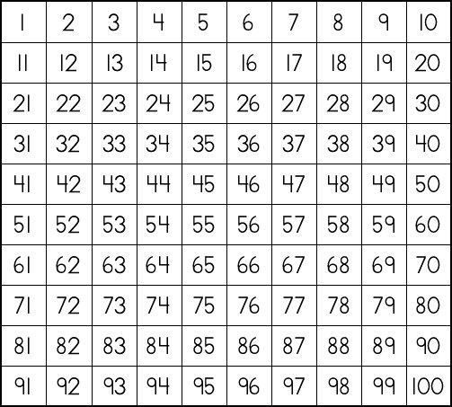

Teacher will ask the student to count by 10s and will make note of any inaccuracies on the recording sheet.
10 | 20 | 30 | 40 | 50 | 60 | 70 | 80 | 90 | 100 | 120

