[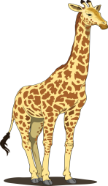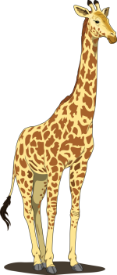](http://freewallpic.com/wp-content/uploads/2014/04/Giraffe-Clipart-Wallpaper-Gigh-Res.png)

[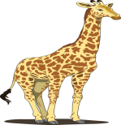](http://freewallpic.com/wp-content/uploads/2014/04/Giraffe-Clipart-Wallpaper-Gigh-Res.png)

Taller Shorter Same size