Student sheet (March)
Name __________
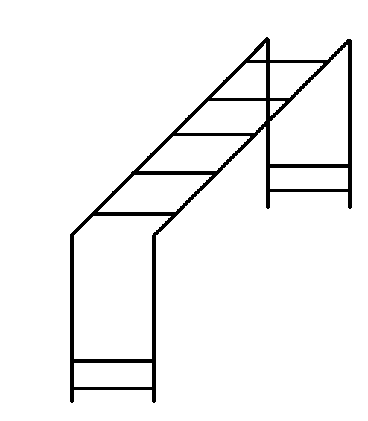
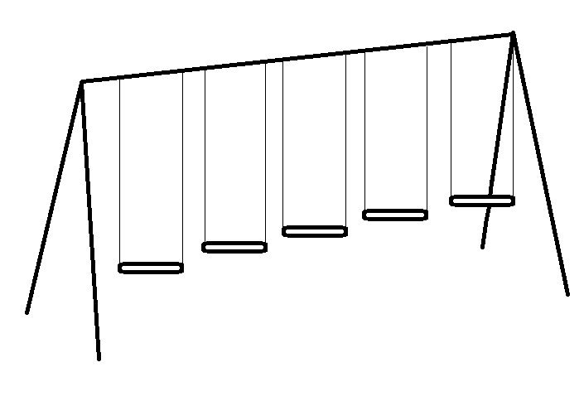

Student Sheet (March)
Name _____________
5 children were at the table. 3 went to get their snack. How many children are left at the table?
