Student sheet (March)
Understands addition as putting together and subtraction as taking apart
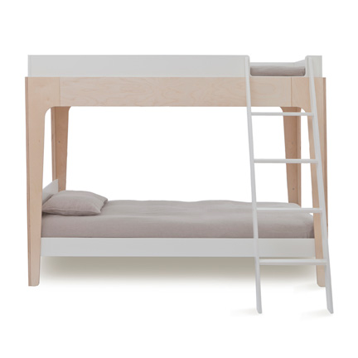
Students will consistently decompose numbers less than or equal to 10 in more than one way using objects.

