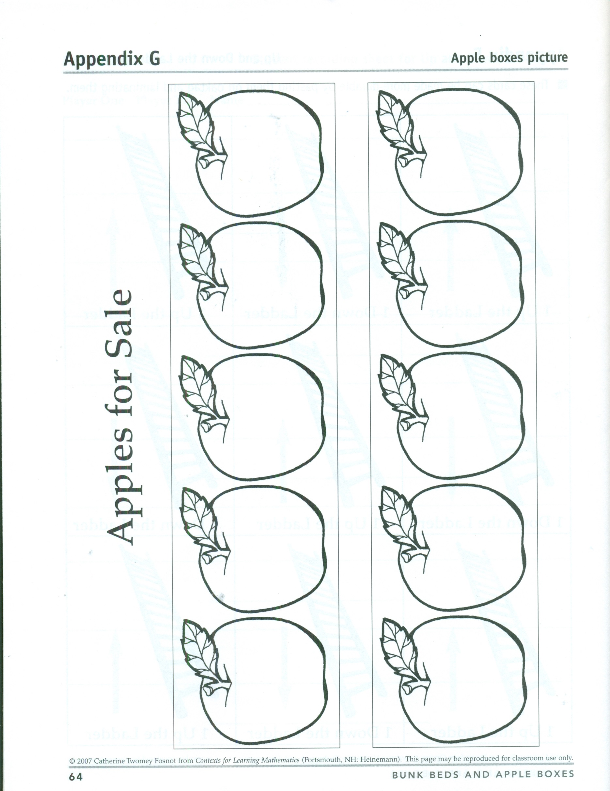

Gr K U5 L11 Appendix G