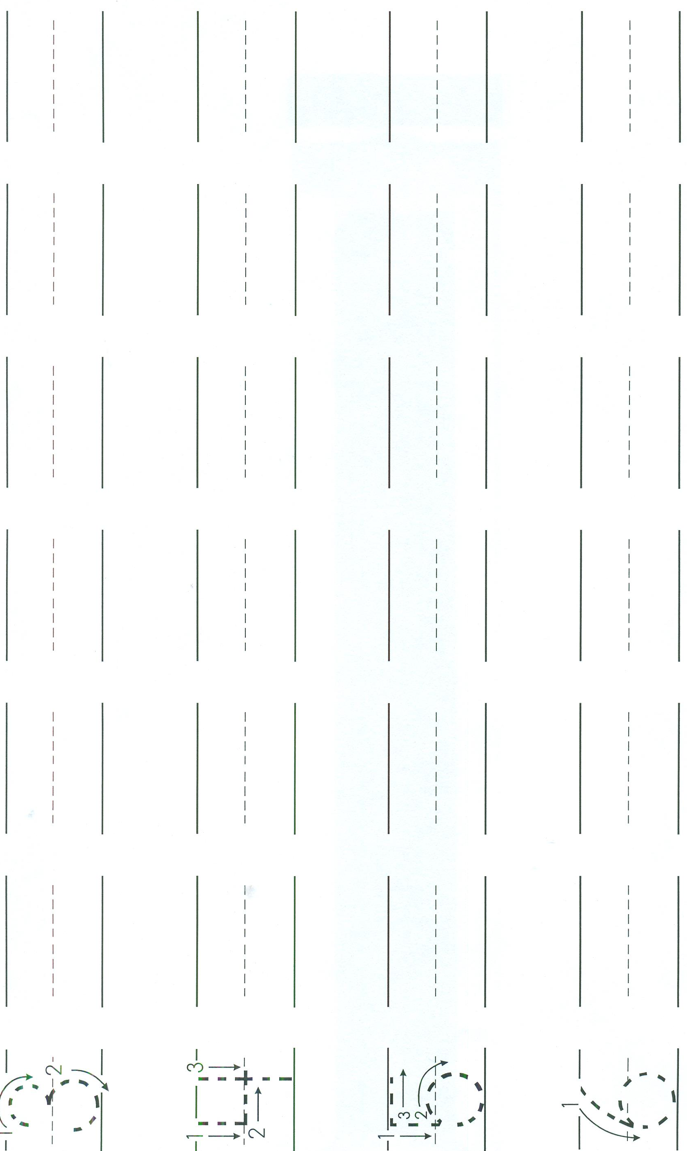
Name ________________________________________ Date_____________________________

