[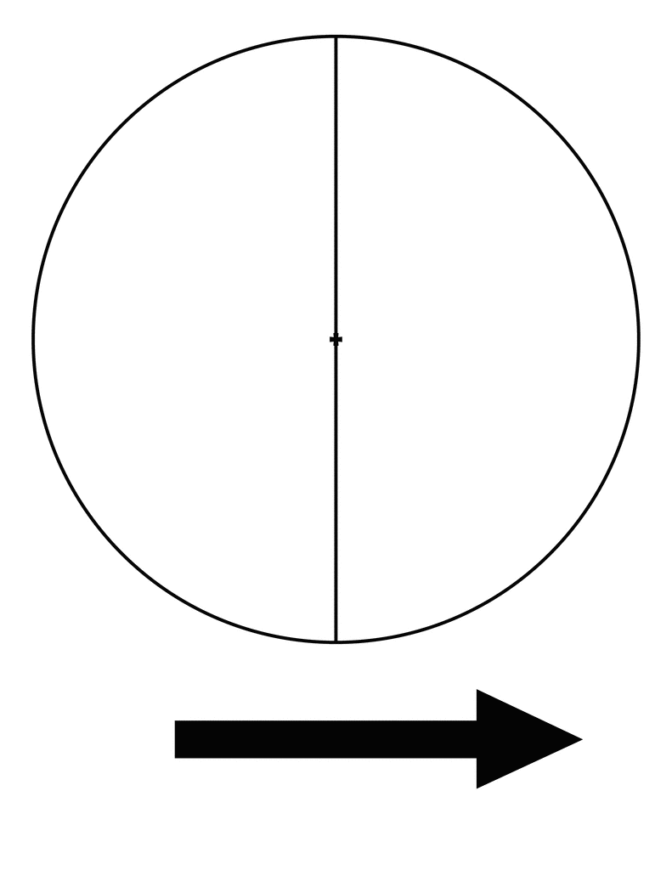](http://www.google.com/url?sa=i&rct=j&q=2%20spinner%20clip%20art&source=images&cd=&cad=rja&docid=p70PZzYqZND7IM&tbnid=9zMjcWZ5Qs7x9M:&ved=0CAUQjRw&url=http://etc.usf.edu/clipart/37700/37706/spinner-02_37706.htm&ei=427pUcTrB5jb4APewIG4Bw&bvm=bv.49478099,d.dmg&psig=AFQjCNEHBvKAYv6RaEltD_6JgijIYtXIJg&ust=1374339169171780)

+ -