[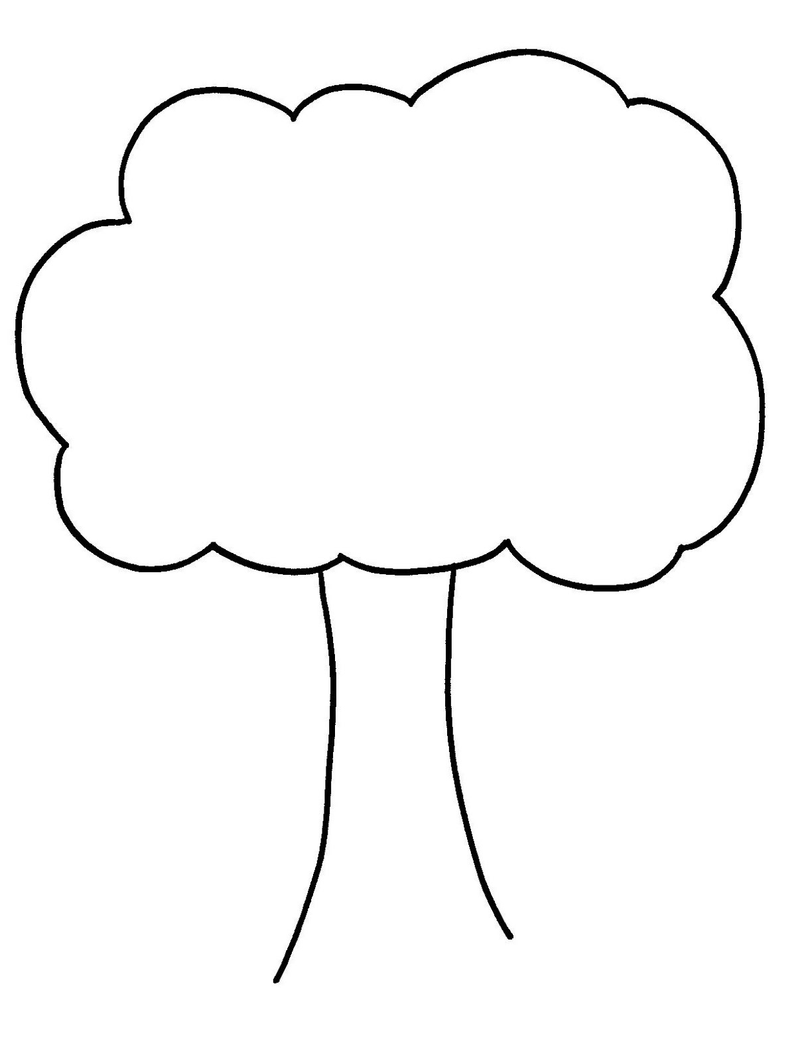](http://www.google.com/url?sa=i&rct=j&q=tree%20outline&source=images&cd=&cad=rja&docid=_WCYgzuH_Imj7M&tbnid=YMb70Gd3SiG3QM:&ved=0CAUQjRw&url=http://www.picstopin.com/652/printable-apple-tree-leaf-templates/http:||123coloring*com|coloringpages|animals|turtles|page%202|images|tortue21*gif/&ei=6ETtUbjTHIX_4AOTmoGwDA&bvm=bv.49478099,d.dmg&psig=AFQjCNGDdB8wakzWpSR-25uXiUgc_XtP_w&ust=1374590556981712)