[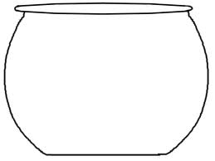](http://www.google.com/url?sa=i&rct=j&q=fish+bowl+outline&source=images&cd=&cad=rja&docid=bzAmnE1Zxe7AGM&tbnid=gBPaGRDwHhdV7M:&ved=0CAUQjRw&url=http://beautifulife-er.blogspot.com/2013/01/valentine.html&ei=jUftUY7eNNi84AOgyYGICw&bvm=bv.49478099,d.dmg&psig=AFQjCNEsFIzIP2qtg_Iae8ncyZGnRvOkAg&ust=1374591243847204)