Name : ____________________________________ Date: _________________

Answer the following questions.

How much of each figure below is shaded?

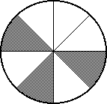

**1. 2.**

________ ________

1. What fraction of the squares is shaded?

___________

1. Write 2 fractions that are equivalent to . _________ and _________
2. Write  as an improper fraction. ___________
3. Write  as a mixed number. ___________

What number goes in the □ to make the fractions equivalent?

**7**.  □ = _______ **8**.  □ = _______

1. 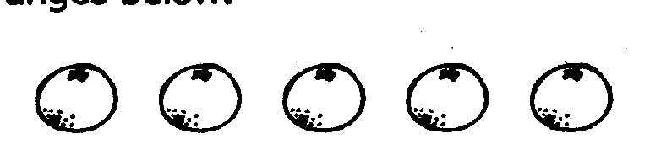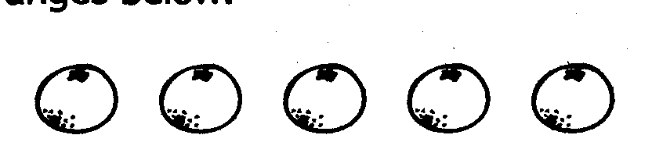Draw a ring around  of the oranges below.

1. Label the benchmark fractions on

the number line.

1. What fraction is located where the

dot is on the number line?

**0** **1**

___________

Use <, >, or =

**12**.  _**__**_  **13. $\frac{4}{12}$ $\frac{1}{3}$____**   **14. $\frac{6}{8}$ $\frac{2}{8}$** ____

Answer the following questions.

1. Amy, Beth, and Chuck participated in a watermelon eating contest. Amy ate  of her watermelon, Beth ate  of her watermelon, and Chuck ate of his watermelon. Who came in first place (ate the most watermelon)? Who came in second place? Explain your thinking.
2. Is $\frac{3}{8}$ closer to $\frac{1}{2}$ or 1 whole? Explain your thinking.