How much of each figure below is shaded? ***(1pt each)***

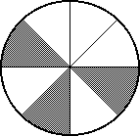

1. **2.**

 

1. What fraction of the squares is shaded? ***(1pt)*** 

1. Write 2 fractions that are equivalent to. ***(1pt for each fraction named)***

**, , , etc.**

1. Write  as an improper fraction.  ** *(1pt)***

1. Write  as a mixed number.  ** *(1pt*)**

What number goes in the □ to make the fractions equivalent? ***(1pt each)***

**7**.  □ = **8** **8**.  □ =  **4**

1. 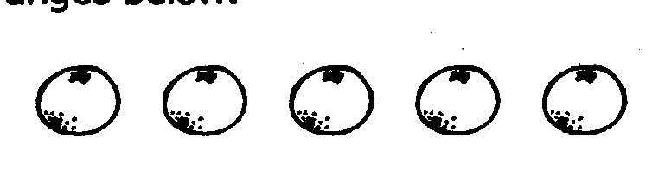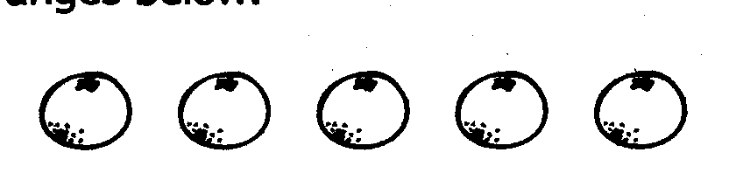Draw a ring around  of the oranges below. ***Ring any 4 of the oranges.***

***(1pt)***

1. Label the benchmark fractions

on the number line.  ***(1pt)***

1. What fraction is located where the

dot is on the number line?

**0 1   *(1pt)***

Use <, >, or = ***(1pt each)***

**12**.  **<**  **13. $\frac{4}{12}$ = $\frac{1}{3}$**   **14. $\frac{6}{8}$** **> $\frac{2}{8}$**

1. Amy, Beth, and Chuck participated in a watermelon eating contest. Amy ate  of her watermelon, Beth ate  of her watermelon, and Chuck ate of his watermelon. Who came in first place (ate the most watermelon)? Who came in second place? Explain your thinking.

***Beth ate the most watermelon and Chuck came in second place. There are many ways for students to accurately solve this problem****.* ***Give 1pt for explaining why  >* *, 1pt for explaining why  > ; and 1 point for explaining why*  > . *(These are the three sub-problems contained in problem #15). (3pts)***

1. Is $\frac{3}{8}$ closer to $\frac{1}{2}$ or 1 whole? Explain your thinking.

***Give 1pt for the answer and 1pt for explaining their thinking. (2pts)***