Name: Name: Date:

Leanne created a route for Jenna to follow on the playground. She started at the edge of the building and ended at the swings. Your job is to help her write directions that follow her path. Use a ruler to measure the path to the nearest centimeter. Each centimeter represents two meters. At each turn tell which direction to turn and how many degrees of a turn. The vision line (dotted line) indicates the direction Jenna will be facing and the direction from which she will turn.
Example:
Fwd 2 meters
Key
1 cm = 2 meter
Turn Left 90˚
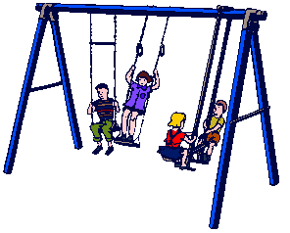
Swing

6 cm
End
2 cm
(Vision Line)
3 cm
(Vision Line)
s
8 cm
(Vision Line)
Four squares
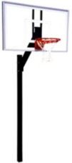
4 cm
Basketball
(Vision Line)
10 cm
4 cm
(Vision Line)
Building

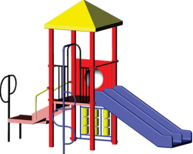
Slide

Start

Directions
Start at edge of building
FWD 8 meters
RT 90˚
FWD 20 meters
Lt 90˚
FWD 8 meters
Lt 90˚
FWD 16 meters
RT 45˚
FWD 6 meters
RT 45˚
FWD 4 meters
RT 90˚
FWD 12 meters

Rubric Scores
3 - Full and complete understanding of angle and linear measure. Directions and measurements are accurate.
2 – Minor errors in measurement, e.g. measures 40˚ instead of 45˚ or measures the interior angle rather than the direction of the rotation (135˚). Student attempts to measure to the nearest millimeter instead of rounding to the nearest centimeter. Student does not convert from centimeters to meters
1 – Student writes an angle and linear measure but does not indicate units, degrees (˚) or cm. Students angle measures are off by 10˚ or more. Student linear measurements are inaccurate to within a ¼ cm.
0 – There is insufficient information to indicate student understanding of angle and linear.

